

All members of staff in our school are committed to safeguarding all our children

We will strive to:

- Create and maintain a safe learning environment for our children

- Identify where there are child welfare concerns and take action to address them, in partnership with other organisations where appropriate.

- Develop our children’s understanding of how to keep themselves safe

Signed: 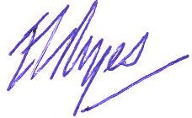 Headteacher
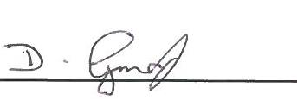 Chair of Governors

